LIVING DONATION INFORMATION

Could I be a living kidney donor?

It explains the donation and transplantation process and how relatives and friends can give their loved one the chance of a normal life by donating one of their kidneys.

The shortage has lead to increasing numbers of families and friends asking if they can donate one of their own kidneys.

All organs are matched between donor and recipient by size and blood group, but kidneys are also matched by tissue type.
When living donors and patients are close relatives, the chance of finding a good match of tissue type and blood group are improved, as are the chances of a successful transplant.

Living transplantation has become more important because of the shortage of donated organs from deceased donors and the steadily increasing number of people needing a transplant.

We are keen to give more people the chance to consider living donation because it is so successful and has such a positive impact, not only on the person with kidney disease but their family as well.”
The new leaflet will be offered to patients and their families following diagnosis of kidney disease which could lead to a planned transplant, perhaps even before their loved one has to undergo renal dialysis.

This new leaflet is a useful source of information for people who might be prepared to consider donating a kidney to a loved one or a friend, but who may not know very much about it or how to proceed. It is designed to give people straightforward answers to frequently asked questions.
“Most people, given the choice, would prefer to plan their lives ahead. Living donation offers patients with kidney failure and their families the opportunity to do this and the earlier the information is made available to them, the sooner they can consider their options.
“We hope that this leaflet will encourage people to think about what is best for them at an earlier stage so that more patients benefit from a kidney transplant before they need dialysis.”

Donating a kidney is a major decision and it takes courage to be a kidney donor. There are many things that you should know before considering kidney donation and this leaflet hopes to answer some of your questions.
Kidneys may be donated by people who have died or by living donors who wish to help a loved one.
It is important that anyone who wants to be considered as a living kidney donor thinks seriously about the possibility.
Points to consider are:
- the survival of transplants from living donors is significantly better, allowing more people to receive and benefit from a kidney transplant
- living donors who are close relatives can be an excellent tissue-type match for the recipient and this can be an added bonus for the recipient
- unrelated donors, such as spouses, are unlikely to be well matched to the recipient. However, in all but the perfectly matched situation, the success rates of these transplants are equal to those of related donors
- living kidney donation allows the transplant operation to be planned at a time that is convenient for the recipient and the donor and for some people this can be planned before the need for dialysis
- recipients who are transplanted prior to dialysis have better long-term transplant survival.
- the number of people needing kidney transplants continues to increase
- there are not enough kidneys from donors who have died available for transplant
- the average waiting time for a kidney transplant is two and a half to three years and for some minority ethnic groups it may be more than five years.

Who can donate?
Donors are often a close relative such as a parent, brother or sister, son or daughter. They can also be other individuals who are not related but who have an established emotional relationship with the recipient such as a partner or close friend.

What is the age range for being a donor?
In the United Kingdom, only people over 18 years of age would be considered as living kidney donors. There is no upper age limit, but all potential donors must meet the criteria to establish that they are fit to donate.

How will I know if I am suitable to donate?
You will have a thorough medical and surgical assessment to establish that you are fit and healthy to donate. A number of people who wish to donate find that they are not able to do so because health problems are discovered through the assessment process. Members of the healthcare team involved in your assessment include counsellors, co-ordinators and social workers.

Are there any risks to me?
All operations carry some risk and this is no different for living donation. Donors are at risk of infections (eg chest, wound or urine) and, more rarely, bleeding or blood clots. There is a very small risk of death for the donor: this is estimated at 1 in 3,000 for this operation.

Are there any long-term risks?
There is a small possibility of a slight rise in blood pressure and excess protein in your urine. However studies have shown that there is no long-term effect on the donor or your remaining kidney.

Am I at greater risk of developing kidney failure?
You are at no greater risk of developing kidney failure after donating than anyone in the general population.

Will it shorten my lifespan?
Studies have shown that donors live longer than the average population. This is because donors are selected on the basis of good health and are thoroughly screened prior to donation.

Will I have to change my lifestyle after donating?
No. You should lead a normal healthy life as before.

Will donating my kidney affect a future pregnancy or fathering a child?
The small amount of data available shows that, having donated one kidney, there is no evidence to suggest an increased risk of complications during pregnancy. A man’s fertility will not be affected.

Will I be covered by my health insurance?
You should check with your insurance company.

What if I live in a different part of the UK from the person I am donating to?
You can still donate. The transplant team will organise for your medical assessment to take place at a hospital near you if that is more convenient for you. The donation will take place where the person you are donating to is cared for.

What if I live overseas?
You can still donate. Some preliminary tests can be arranged in your own country to see if you will be a suitable donor.
and initial blood tests.

What governs living organ donation in the UK? What are the religious views on living donation?
Most religions support living donation as they view it as a gift to a loved one. If you have any doubt, you should contact your religious leader.

How long does the donor assessment process take?
In general, this will take at least three months. There is variation depending upon where you live and what tests you may require. Wherever possible, the assessment is tailored to your needs and commitments.

How much time will I need to take off work?
Most transplant centres will try to arrange the tests and investigations before the operation around your work schedule to minimise disruption to your job. It is sometimes possible to arrange for some of this to be done locally if the donor lives a long way from the transplant centre. The operation and recovery period varies from 2 - 12 weeks depending on surgery, your individual recovery and the type of work you will be resuming.

How will I be able to afford time off work?
You should discuss this with your employer and find out what is available under your (their) terms of employment around Statutory Sick Pay. You may be eligible for reimbursement of loss of earnings and costs. However, reimbursement is at the discretion of the recipient’s health care providers. You will need to discuss this with your transplant team.

What if I am in receipt of a benefit such as job seeker’s allowance?
You should take advice about this by contacting your local Citizens Advice Bureau.

How is the kidney removed?
You will be given a general anaesthetic which means that you will be asleep during the operation. Traditionally, and most commonly in the UK, the kidney is removed by making an incision in the side or abdomen (tummy). Kidneys can also be removed by keyhole surgery although this is currently only available in a small number of transplant centres in the UK.

How long will the operation take?
The operation takes approximately two hours and you will have a urinary catheter and a drip when you return from theatre.

How long will I be in hospital?
This varies depending on your individual recovery. The average stay is four to ten days.

Will I experience a lot of pain?
Strong pain relief will be provided to help alleviate pain and discomfort after the operation.

Will I need to take any medication after donating?
You will need to take some painkillers immediately after the operation and during the recovery period. You may also be prescribed antibiotics for a short period if you need them. However, you will not need any long-term medication as a result of kidney donation.

What about follow-up?
You would usually be seen by the transplant team between two and six weeks after donation. We recommend that you attend an annual follow-up appointment, if you wanted this, for the rest of your life.

Do some donors have trouble making the decision?
Some people make the decision easily. Others go through some soul searching before deciding. Being afraid of donating a kidney or feeling guilty about not wanting to donate is quite normal. The only “right” decision is the one that makes you, the potential donor, feel comfortable. Finding out more information about living donation and what it involves may help you with this decision.

Can I speak to somebody who has donated?
Your co-ordinator at your local transplant centre should be able to arrange this for you.

Suppose I decide against being a donor?
You have the right to withdraw your offer at any time and you would be supported in your decision by the transplant team.

Who makes the final decision?
Once all the tests have been completed and found satisfactory by the transplant team, a date is set for the operation. The transplant will only take place if both the donor and recipient are willing to proceed.

Will the transplant be successful?
There is no guarantee that any kidney transplant will work. However, living kidney transplantation is overwhelmingly successful with 90-95% of live donated kidneys working well at one year. This compares with a success rate of 85-90% for kidneys from deceased donors.

What is the first thing I should do if I am thinking about being a donor?

You will need to contact the transplant centre where the patient (intended recipient of your kidney) is being cared for. The first piece of information we would need to know is your blood group to see if it is compatible with your recipient. After this an appointment will be arranged for more detailed discussion
The legal framework around organ and tissue donation, including living donation, is currently under review and the specifics may, therefore, change in the future. Currently, if the potential donor and recipient are not genetically related the transplant must be approved by a government body called the Unrelated Live Transplant Regulatory Authority (ULTRA). This authority is in place to prevent coercion, pressure or payment for organs, which is illegal in the UK.
Sources:
UK Guidelines for Living Donor Kidney Transplantation, BTS and Renal Association, January 2000
Living Donor Kidney Transplantation - Your Questions Answered, Roche 2002

Waiting Time on Dialysis as the Strongest Modifiable Risk Factor for Renal Transplant Outcomes, Meier-Kreische, H-U, Kaplan, B. Transplantation, vol. 74, 1377-1381, no.10, November 27, 2002

Transplants transform lives
Transplants are one of the most miraculous achievements of modern medicine.
They involve the donation of organs from one person to another and enable about 2,700 people to take on a new lease of life in the UK every year.
Transplants are the best possible treatment for most people with organ failure.
Kidney transplants are the most commonly performed. Transplants of the heart, liver and lungs are also regularly carried out. As medicine advances, other vital organs including the pancreas and small bowel are also being used in transplants. Tissue such as corneas, heart valves, skin and bone can also be donated.
The increasing effectiveness of transplantation means that many more patients can be considered for treatment in this way. But there is a serious shortage of donors.
For some people this means waiting, sometime for years, and undergoing difficult and stressful treatment. For all too many it means they will die before a suitable organ becomes available.
UK Transplant is committed to saving or dramatically improving many more lives by increasing the number of organs available for donation.
Can you donate an organ while you are still alive?
Yes, in some cases. The shortage of organs has led to an increasing number of organ donations by living people.
The most common organ donated by a living person is a kidney as a healthy person can lead a completely normal life with only one functioning kidney. Kidneys transplanted from living donors have a better chance of long-term survival than those transplanted from people who have died. There are a number of reasons for this, the main one being that the donor is alive and healthy. About one in five of all kidney transplants are from a living donor.
Most living donor kidney transplants are between close family members because they usually provide the best match. The donor might be a brother, sister, mother, father, aunt, uncle, grandparent or child. The majority are between parent and child but living donor kidney transplants between people who are not blood relatives - such as husband and wife or between partners or close friends - are becoming increasingly common.
Before a living donor transplant can go ahead there are strict regulations to meet and a thorough process of assessment and discussion.
Part of a liver can be transplanted and it is also possible to donate a segment of a lung and, in a very small number of cases, part of the small bowel.
Hearts are also donated by living people. This is because for some patients with diseased lungs who need a lung transplant it is more effective to give them a combined heart and lung transplant, even though their heart is perfectly healthy. In these cases, the patient's healthy heart is then transplanted into a patient needing a heart transplant. This is known as a "domino" transplant.
http://www.pharma-lexicon.com/medicalnews.php?newsid=17450&language=spanish

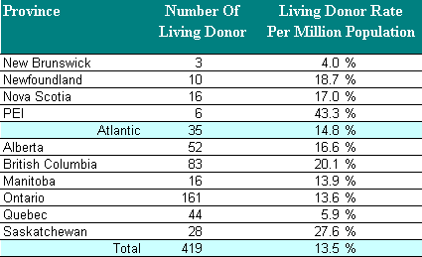

http://www.cdha.nshealth.ca/transplantservices/kidney.html

How Do You Become a Living Kidney Donor?
By Sharon Larsen
Return to Home
There are two types of living donors - related and unrelated. In the medical world I am what is known as a LURD - a Living Un-Related Donor. How could that be? I donated a kidney to my husband - we're related - we've got a piece of paper that says so! But, "unrelated" in the medical sense is quite specific, "no blood relation", and in that sense, we are un-related.
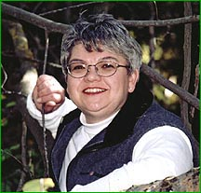  Sharon Larsen | Choosing to become a living organ and tissue donor is a very personal and important decision. I have been asked many times about how I made my decision and I have yet to be able to clearly and accurately define the process I used. Very simply put, the question for me was not "would I" but rather "could I" donate.
The testing to become a living donor started with a psychosocial interview with the Transplant Coordinator of the HOPE (Human Organ Procurement and Exchange) Living Donor Program. During this meeting I answered a number of very personal questions about my health, lifestyle and the reasons why I wanted to donate a kidney. Simply put, the Transplant Team needed to know that I knew what I was doing, what was involved, why I was doing it and to satisfy themselves that my decision to donate was an informed decision made freely by me.
  Gordon Larsen | The most critical component of being a living kidney donor is blood and tissue type testing. Compatibility of blood types and matching antigens between the donor and recipient is the most important factor. The more compatible the tissue type, the less likely the recipient's immune system will reject the transplanted kidney. A number of blood tests were conducted to determine whether there was a suitable match with my husband. One of blood tests was a cross match or "test tube transplant" which involved mixing our blood together to determine the antigen match and compatibility of the cells.
Additionally, and no less important, was my general health. I underwent a complete physical examination, general blood work, a routine urinalysis, a 24 hour urine collection, electrocardiogram, chest x-ray and abdominal ultrasound. The final test was a renal angiogram - a day procedure where special dye was injected into a vessel in my groin and x-rays taken while the dye flowed from the injection site through the blood vessels to my kidneys. These x-rays provided a "blue print" for the transplant surgeon.
Once all the testing was completed, our individual medical records were reviewed by the Transplant Team and the decision was made. Yes, I could be a donor.
On September 14th we will celebrate our 2nd Kidney-versary. MYO (yes, we named our kidney - "Mine, Yours, Ours") is doing great. And No, I have no adverse effects from the surgery or from having only one kidney. Would I do it again? If I could, in a New York minute.
Our story is a very happy story. Our transplant was a very successful transplant. And, although it is "our story" and "our transplant" there were, and continue to be, others who can share in our happy story and successful transplant - the medical community of the Department of Nephrology and Immunology, University of Alberta Hospital.
http://www.givethegiftoflife.org/write/living.htm

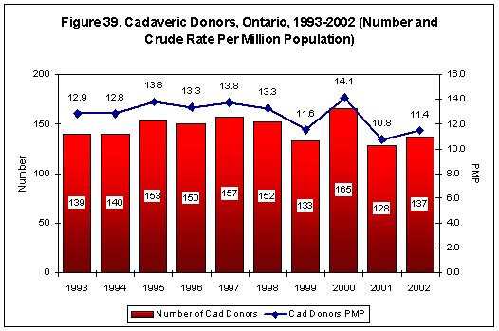
http://secure.cihi.ca/cihiweb/en/reports_corrinsites_apr2003_ont_f39_e.html

Close Window
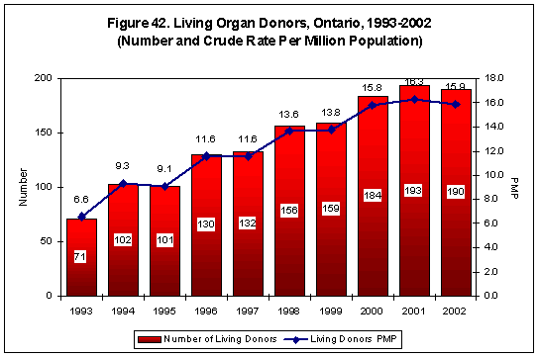
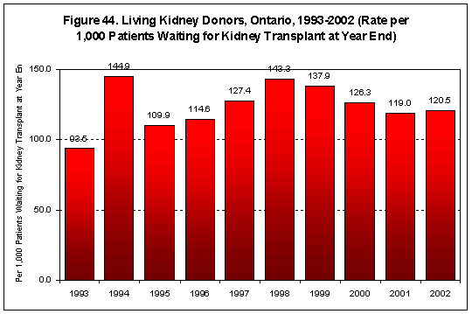
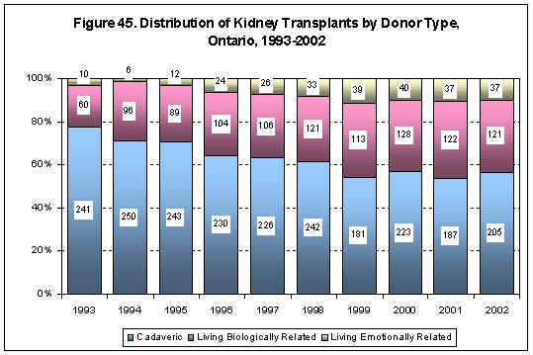
http://secure.cihi.ca/cihiweb/dispPage.jsp?cw_page=reports_corrinsites_apr2003_ont_e

Did you know that fewer than 15 Canadians in a million are organ donors?

It's true.
Canada's organ donation rate ranks in the bottom half of countries in the western world where transplants are performed. More than 3,500 Canadians are waiting for an organ transplant, and every year nearly 150 of them die, waiting.
We have some of the best transplant technology in the world, some of the most highly skilled surgeons, some of the most prestigious transplant hospitals, but there are never enough organs available to save enough lives.
Too few Canadians decide to become potential organ and tissue donors. Too few Canadians talk about that decision with their families.
To help you make an enlightened decision, Canada's National Organ & Tissue Information Site dispels common myths and presents clear-cut information about donation and transplantation.
http://www.hc-sc.gc.ca/english/organandtissue/facts_faqs/

Religion | Position
Amish | The Amish consent to donation when it benefits the health and welfare of the transplant recipient. Amish are reluctant to donate organs if the transplant is unlikely to succeed or if the organs will be used for research.
Buddhism | Buddhists believe organ donation is a personal decision and should be left to an individual's conscience. Because donation is a noble act, Buddhism honours those people who donate their bodies and organs to advance medical science and save lives.
Catholicism | Catholics view organ donation as an act of charity, self-sacrifice, and love for others. Transplants are ethically and morally acceptable.  "Organ transplants conform with the moral law if the physical and psychological dangers and risks incurred by the donor are proportionate to the good sought for the recipient. Donation of organs after death is a noble and meritorious act and is to be encouraged as a manifestation of generous solidarity. It is not morally acceptable if the donor or those who legitimately speak for him have not given their explicit consent."  Catechism of the Catholic Church, 1992, number 2296  top
The Church of Christ Science | Christian Scientists rely on spiritual rather than medical means for healing. The Church opposes medical endeavors, including organ transplants. However, individual church members may agree to organ donation.
Gypsies | Gypsies, on the whole, are against organ donation. Although the Gypsy community has no formal resolution, Gypsies believe that for one year after a person dies, the soul retraces its steps. All of the body parts must be intact because the soul maintains a physical shape.
Hinduism | Organ donation is an individual decision. Hindus are not prohibited by religious law from donating. Donation of tissue and organs to save a life would take precedence over the requirement that the dead should be cremated whole, unmutilated from head to toe.  Dr. Madhu Sahasrabudhe  top
Islam | Although Muslims believe that human remains should be kept intact, organ donation is permitted because saving lives is a priority. As long as certain conditions are met, transplantation is not forbidden.
Jehovah's Witnesses | According to the Watch Tower Society, the religion's legal corporation, Jehovah's Witnesses do not encourage organ donation, but believe the matter is best left to an individual's conscience. Jehovah's Witnesses may receive a transplant but only if the transplanted organs and tissues are completely drained of blood.
Judaism | Judaism views the saving of life as a supreme value. Organ or tissue donation to save life is thus not merely an option, it is the fulfillment of a sacred obligation.  Organ and tissue donation from a living donor is not considered to be obligatory when the kindness carries even a small element of risk to the donor. But living donation is lauded as a noble deed of life saving.  Cadaveric donations can only be made after death has been established by such criteria as BSD (Brain Stem Death). It is likewise vital that the dignity of the deceased be respected, that only the organ or tissue necessary for life saving be taken, and that the remainder of the body be respectfully transferred to the Jewish Burial Society of the deceased's locale as soon as possible for interment.  Rabbi Dr. Reuven P. Bulka  top
Mormons | The Church of Jesus Christ of Latter Day Saints considers the decision to donate organs a personal one.
Protestantism | Protestants encourage and endorse organ donation.
http://www.hc-sc.gc.ca/english/organandtissue/my_religion/index.html
Living Donation Debate - Revisiting an "old" subject
submitted by Jane Drew, reprinted by permission from Transplant Team, Vol.2, No.1, Spring 2000
Several complex ethical issues were raised in well-attended sessions on living donation, at the Canadian Association of Transplantation (CAT) meeting in Mont Tremblant, Quebec, March 2-4, 2000.
Two speakers from the London Health Sciences Centre related their experiences with kidney and liver transplants from living donors. Jennifer Cross, Clinical Nurse Specialist and Coordinator for the living donor kidney program, and Dr. Paul Atkison, Director of Paediatric Transplantation, explained the need for careful donor screening, including psychological and social assessment, and follow up. Dr. Atkison noted how living liver donation has grown in this country. Until now, this procedure has been restricted to parent-to-child transplants, but in the very neare future, living liver donation between adults will be performed in Canada. (At the time of press, three adult to adult liver transplants have been performed).
Pressured donors?
Lively discussions that brought up challenging ethical issues followed these informative talks. Participants asked whether parents were able to give altruistic consent in these types of life-and-death situations. What dynamics come into play, for example, when a parent is asked to donate a protion of their liver to their dying child? What kind of pressures do they face? Transplant programs give donors plenty of opportunity to opt out, but what are the forces outside the controlled hospital environment that impact on donors decisions?
Risk of death
The "de-emphasized" risk of mortality, another equally pressing ethical issue, was then pointed out. Reported numbers of people who have died during donation processes range from four worldwide to as high as the mid teens - depending on the source, program, and person quoting the statistics. Transplant programs, understandalby, tend to downplay the deaths of their donors, but this can be misleading. In order to allow donors to make informed choices, doctors need to discuss the risk of death. But with the discrepancy in available statistics, they are basing their comments on "best guesses".
Living kidney donors
The discussion went full circle, back to the ethics of living kidney donation. Although kidney transplantation is seen as "life improving" or "life enhancing", it is rarely "live saving", unlike liver transplantation. The dilemma of risking a donor's life to "improve" a kidney patient's quality of life, was debated.
Future direction
With the chronic shortage of organs and the resulting increasing deaths of patients on the waiting lists, the issue of living donation is back again and will continue to grow. Various centres in Canada are currently preparing to initiate or expand living unrelated donation, living lungs and bowel donation, and adult-to-adult liver donation programs. As transplantation moves in this direction, health care professionals need to be prepared to answer the ethical questions that go along with living donor procedures.
http://www.transplant.ca/news_articles/archive/archive_6.cfm#debate

Understanding the Client's Experience Through the Use of Qualitative Methodology
Judy Belle Brown
Mary Lou Karley
King's University College, School of Social Work
London , Ontario
This paper will present an overview of a qualitative study currently in progress which is being conducted to explore the lived experience of living kidney donors in conjunction with a quantitative study that is exploring long term medical outcomes of living kidney donors. There have been limited studies to date that examine the long term psychosocial outcomes of living donors. Maximum variation techniques were used to select a sample of 12 donors. A semi structured interview guide was used to explore the participants' perceptions, ideas and experiences about living kidney donation. All interviews were audio taped and transcribed verbatim. An interpretive approach was used to guide data analysis. Data analysis occurred concurrently with data collection until theme saturation was achieved. Two researchers independently coded and analyzed the transcripts for key words and themes and then met to compare their analyses. Techniques were used to promote trustworthiness and credibility of data. Through immersion and crystallization, the researchers synthesized the data and identified key themes and concepts.
http://www.uwo.ca/kings/academic_programs/departments/social_work/swpaper.htm

